**CHAPTER-1**

**1 .INTRODUCTION**

Most of the vehicle parks today are not running efficiently. Implementing this system will help in improve organization visitor experience, increase parking utilization and prevent unnecessary capital investments. The system does this by providing more efficient and effective parking enforcement. In this we will utilize the barcode technology. The intention of the utilization of barcode technology have been encouraged in different ways, by using this manually achieved workloads will be decreased simultaneously. Barcode technology is an automated Barcode system enables vehicles to check-in and check-out under fast, secure and convenient conditions. Once the vehicle enters into the system premises the data is retrieved from the data retrieval system and stores the check-in information of a particular vehicle.

The main purpose of the centralized intruder detection system for gated communities using barcode reader information technology project is to develop an application called Vehicle Parking System Using Barcode. The application is based on barcode reader and barcode generator by integrating with the centralized monitoring system, which monitors all the entry and exit of vehicles from the organization.

**1.1EXISTING SYSTEM**

Presently things were going manually, that is maintaining the in & out of vehicle by writing into a book. No database was maintained. If any of the vehicle is robbed from the premise easily it can’t be easily identified**.**

**DRAWBACKS:**

1. It is difficult to maintain the whole database.
2. Users have to spend 1 – 2 minutes for booking the slot.
3. Things were going manually.
4. Time taking process.

**1.2PROPOSED SYSTEM**

Vehicle Parking System Using Barcode is an automated system in which barcode technology is used. Using this software, a user will be authenticated to park his vehicle in the organization using barcode. The unauthorized people who are not allowed to park his vehicle in the organization will be restricted to enter into the premises of the organization at the gate itself.

**1.2.1ADVANTAGES**

* Automated system using IOT.
* All the vehicles information is maintained in database.
* We can get history database also.
* Need less manpower.
* Providing security.

**CHAPTER-2**

**2. MODULE DESCRIPTION**

The project consists of mainly different modules. They are as follows:

* Authentication Module.
* Add Vehicle Module

1) Generate Barcode.

* Scan Vehicle

1) Entry of vehicle.

2) Exit of vehicle.

* Vehicle Details.

1) Delete an entry.

**2.1 AUTHENTICATION**

In This Module the Admin will login with his User name & Password and Get Authentication to the application**.** If Username & password is correct then only it will authenticate otherwise it will not.

**2.2ADD VEHICLE**

In these module we will add the details of new vehicle into our database. Clicking on add button will display the message that vehicle details added successfully.

**2.2.1 GENERATE BARCODE**

The authorized person will generate a barcode for every vehicle added in the database.

**2.3 SCAN VEHICLE**

In this module we will scan the generated barcode through mobile.

**2.3.1 ENTRY OF VEHICLE**

The vehicle no is verified from our database whether it is permitted or not. If vehicle no is available, it is verified & it is displayed into the parking details table.

**2.3.2 EXIT OF VEHICLE**

Again repeating the same process, scanning the barcode from scanner. Barcode will be compared with entry of vehicle list, if entry of the vehicle is present, vehicle can exit from our premises & the data will be removed from vehicles list.

**2.4 VEHICLE DETAILS**

This module shows all the details of each and every added vehicle in our database & we can delete any of the vehicle details from here.

**2.4.1 DELETE AN ENTRY**

We can delete the details of vehicle from our entry.

**CHAPTER-3**

**3. SYSTEM REQUIREMENTS**

The development of the project deals with the following environment

1. Hardware requirements
2. Software requirements

**3.1 HARDWARE REQUIREMENTS**

Processor    :   Any updated processor

Ram           :   Min 1 GB

Hard Disk   :   Min 100 GB.

**3.2 SOFTWARE REQUIREMENTS**

Operating System : Windows family.

Technology           : Java (1.7/1.8).

Building application : Netbeans IDE 8.2

Database      : Oracle jdbc thin database.

UML : Star UML

DFD : DFD Drawer.

Scanner : Barcode reader android application.

**CHAPTER-4**

**4. DATAFLOW DIAGRAM**

**ADD VEHICLE**

**Adding of vehicle Generating barcode for the**

**details.**  **added vehicle**.

**Scanning for the entry & exit of vehicle**

**Authentication of**

**the user is done**.

**AUTHENTICATION**

**SCAN VEHICLE**

**Scanning of vehicle**

**is done here.**

**VEHICLE DETAILS**

**Deletion of vehicle details**.

**CHAPTER-5**

**5.1 NETBEANS IDE 8.2**

Netbeans runs on Windows and Solaris In addition to Java development, it has extensions for other languages like PHPs, C++, HTML5 and JavaScript applications based on Netbeans, including the Netbeans IDE, can be extended by third party developers.

In 1997, Roman Stanek formed a company around the project and produced commercial versions of the Netbeans IDE until it was bought by Sun Microsystems in 1999. Sun open-sourced the Netbeans IDE in June of the following year.

Since then, the NetBeans community has continued to grow.In 2010, Sun (and thus NetBeans) was acquired by Oracle Corporation under Oracle, Netbeans competed with JDeveloper a freeware NetBeans is an integrated development environment(IDE) for Java. NetBeans allows applications IDE that has historically been a product of the company.

The platform offers reusable services common to desktop applications, allowing developers to focus on the logic specific to their application. Among the features of the platform are:

* User interface management (e.g. menus and toolbars)
* User settings management
* Storage management (saving and loading any kind of data)
* Window management
* Wizard framework (supports step-by-step dialogs)
* Netbeans visual library
* Integrated development tools

### GUI DESIGN TOOL

Formerly known as project Matisse, the GUI design-tool enables developers to prototype and design Swing GUIs by dragging and positioning GUI components.

The GUI builder has built-in support for JSR 295 (Beans Binding technology), but the support for JSR 296 Swing Application Framework was removed in 7.1.

**5.2 JAVA**

Java  is general purpose computer programming language  that is concurrent, class-based, object-oriented, and specifically designed to have as few implementation dependencies as possible. It is intended to let application developers "write once, run anywhere" (WORA), meaning that compiled Java code can run on all platforms that support Java without the need for recompilation. Java applications are typically compiled to “bytecode” that can run on any Java virtual machine (JVM) regardless of the underlying [computer architecture](https://en.wikipedia.org/wiki/Computer_architecture). The language derives much of its original features from [SmallTalk](https://en.wikipedia.org/wiki/SmallTalk), with a [syntax](https://en.wikipedia.org/wiki/Syntax_(programming_languages)) similar to [C](https://en.wikipedia.org/wiki/C_(programming_language)) and [C++](https://en.wikipedia.org/wiki/C%2B%2B), but it has fewer [low-level](https://en.wikipedia.org/wiki/Low-level_programming_language) facilities than either of them. As of 2016, Java was one of the most , particularly for [client-server](https://en.wikipedia.org/wiki/Client%E2%80%93server) [web applications](https://en.wikipedia.org/wiki/Web_applications), with a reported 9 million developers.

Java was originally developed by Canadian [James Gosling](https://en.wikipedia.org/wiki/James_Gosling) at [Sun Microsystems](https://en.wikipedia.org/wiki/Sun_Microsystems) ([which has since been acquired by Oracle](https://en.wikipedia.org/wiki/Sun_acquisition_by_Oracle)) and released in 1995 as a core component of Sun Microsystems' [Java platform](https://en.wikipedia.org/wiki/Java_(software_platform)). The original and [reference implementation](https://en.wikipedia.org/wiki/Reference_implementation) Java [compilers](https://en.wikipedia.org/wiki/Compiler), virtual machines, and [class libraries](https://en.wikipedia.org/wiki/Library_(computing)) were originally released by Sun under [proprietary licenses](https://en.wikipedia.org/wiki/Proprietary_license). As of May 2007, in compliance with the specifications of the [Java Community Process](https://en.wikipedia.org/wiki/Java_Community_Process), Sun had [relicensed](https://en.wikipedia.org/wiki/Software_relicensing) most of its Java technologies under the [GNU General Public License](https://en.wikipedia.org/wiki/GNU_General_Public_License). Meanwhile, others have developed alternative implementations of these Sun technologies, such as the [GNU Compiler for Java](https://en.wikipedia.org/wiki/GNU_Compiler_for_Java) (bytecode compiler), [GNU classpath](https://en.wikipedia.org/wiki/GNU_Classpath) (standard libraries), and [IcedTea](https://en.wikipedia.org/wiki/IcedTea)-Web (browser plugin for applets).

The latest version is [Java 11](https://en.wikipedia.org/wiki/Java_version_history), released on September 25, 2018, which is a currently supported [long-term support](https://en.wikipedia.org/wiki/Long-term_support) (LTS) version by [Oracle](https://en.wikipedia.org/wiki/Oracle_Corporation). Since Java 9 is no longer supported, [Oracle](https://en.wikipedia.org/wiki/Oracle_Corporation) advises its users to "immediately transition" to Java 11. Oracle released the last public update for the [legacy](https://en.wikipedia.org/wiki/Legacy_software) Java 8 LTS, which is free for commercial use, in January 2019. Java 8 will be supported with public updates for personal use up to at least December 2020. Oracle and others "highly recommend that you uninstall older versions of Java" because of serious risks due to unresolved security issues.

**5.2.1 FEATURES OF JAVA**

Java is a general-purpose programming language developed with the aim to bring portability and a higher level of security. Other than these two main**java features**, there are many other features of Java that make it such a unique and popular language.

The essential aspects included in object-oriented approach

* Inheritance
* Polymorphism
* Platform Independence
* Robust
* Security
* Dynamic Binding

**5.2.1.1 INHERITANCE**

Inheritance in java is a mechanism in which one object acquires all the properties and behaviors of a parent object. It is an important part of OOPs (Object Oriented programming system). The idea behind inheritance in java is that you can create new classes that are built upon existing classes.

**5.2.1.2 POLYMORPHISM**

Polymorphism is the ability of an object to take on many forms. The most common use of polymorphism in OOP occurs when a parent class reference is used to refer to a child class object. Any java object that can pass more than one IS-A test is considered to be polymorphic.

**5.2.1.3 PLATFORM INDEPENDENCE**

Platform independent language means once compiled you can execute the program on any platform (OS). Java is platform independent. Because the **java** compiler converts the source code to bytecode, which is Intermediate Language. Bytecode can be executed on any platform (OS) using JVM( Java Virtual Machine).

**5.2.1.4 ROBUST**

Java is Robust because it is highly supported language. It is portable across many Operating systems. Java also has feature of Automatic memory management and garbage collection. Strong type checking mechanism of Java also helps in making Java Robust. Bugs, especially system crashing bugs, are very rare in Java.

**5.2.1.5 SECURITY**

Security features — cryptography, authentication and authorization, public key infrastructure, and more — are built in. The Javasecurity model is based on a customizable "sandbox" in which Java software programs can run safely, without potential risk to systems or users.

**5.2.1.6 DYNAMIC BINDING**

Static binding in Java occurs during compile time whiledynamic binding occurs during runtime. ... Overloaded methods are bonded using static binding while overridden methods are bonded using dynamic binding at runtime.

**5.3 JFRAME**

Swing is a GUI widget toolkit for Java. It is part of Oracle's Java Foundation Classes (JFC) – an API for providing a graphical user interface (GUI) for Java programs.

Swing was developed to provide a more sophisticated set of GUI components than the earlier Abstract Window Toolkit (AWT). Swing provides a look and feel that emulates the look and feel of several platforms, and also supports a pluggable look and feel that allows applications to have a look and feel unrelated to the underlying platform. It has more powerful and flexible components than AWT. In addition to familiar components such as buttons, check boxes and labels, Swing provides several advanced components such as tabbed panel, scroll panes, trees, tables, and lists.

Unlike AWT components, Swing components are not implemented by platform-specific code. Instead, they are written entirely in Java and therefore are platform-independent. The term "lightweight" is used to describe such an element.

**5.4. JAVA DATABASE CONNECTIVITY**

**5.4.1 Establishing a Connection:**

The first thing you need to do is establish a connection with the DBMS you want to use. This involves following steps:

**5.4.2 Loading Drivers:**

Loading the driver or drivers you want to use is very simple and involves just one line of code. If, for example, you want to use the JDBC-ODBC bridge driver, the following code will load it.

**5.4.3 Class.forName(“sun.jdbc.odbc.JdbcDriver”);**

Your driver documentation will give you the class name to use. For instance, if the class name is jdbc.DriverXYZ, you would load the driver with the following line of code.

**Class.forName (“jdbc.DriverXYZ”);**

You do not need to create an instance of a driver and register it with the DriverManager because calling Class.forName will do that for you automatically. If you were to create your own instance, you would be creating an unnecessarily duplicate, but it would do no harm. When you have loaded the driver, it is available for making a connection with a DBMS.

**5.4.4Making the Connection:**

The second step in establishing a connection is to have the appropriate driver connect to the DBMS. The following line of code illustrates the general idea;

Connection con=DriverManager.getConnection(url,”mylogin”,”mypassword”);

**5.4.5Creating JDBC Statements:**

A statement object is what sends your SQL statement to the DBMS. You simply create a Statement object and then execute it, supplying the appropriate. Execute method when the SQL statement you want to send. For a SELECT Statement, the method to use is executeQuery. For statements that create or modify tables, the method to use is ExecuteUpdate. It takes an instance of an active connection to create a statement object. In the following example, we use our Connection object to create the Statement object stmt:

**Statement stmp=con. createStatement();**

At this pint stmt exists, but it does not have an SQL statement to pass on to the DBMS. We need to supply that to the method we use to execute stmt. For example, in the following code fragment, we supply executeUpdate with the SQL stmt.executeUpdate(“CREATE TABLE COFFEES”+

”COF_NAME,SUP_ID INTEGER,PRICE FLOAT,”+

”SALES INTEGER, TOTAL INTEGER”);

Since we made a string out of the SQL statement and assigned it to the variable create TableCoffees, we could have written the code in this alternate form:

**Stmt.executeupdate(create TableCoffees);**

**Executing Statements:**

We used the method executeUpdate because the SQL statement contained in create TableCoffess is a DDL (Data Definition Language) statement. Statement that create a table, alter a table, or drop a table are all examples of DDL statements and are executed with the method executeUpdate. In practice, executeUpdate is used far more often to update tables than it is to create them because a table is created once but may be updated many times.

The method uses most often for executing SQL statements is executeQuery. This method is used to execute SELECT statements, which comprise the vast majority of SQL statement. You will see how to use this method shortly.

**5.4.6 When to use a Prepared Statement Object:**

If you want to execute a statement object many times, it will normally reduce execution time to use a PreparedStatement object instead. The main feature of PreparedStatemet is that, unlike a statement object, is given a SQL statement when it is created. The advantage to this is that in most cases, this SQL statement when it is created.

**5.5 Description of Back end**

**ORACLE 10g:**

The g stand for grid computing. A common misconception seems to be that grid is just the new name for RAC(having improved RAC). This is not the case. 10g comes with both RAC and grid. One will be able to install 10g with RAC only or with grid only, without either and with both. There is profound difference between grid and RAC

One of the goals for 10g was to deliver a complete, integrated stack of software so as to make it possible for oracle users to not have to depend any more on third party software.

This lead to 12 development focus areas for 10g:

* Application Development
* Business intelligence and data warehousing clustering
* Content management
* High availability
* Information integration
* Life sciences
* Location services
* Performance and scalability
* Security and directory
* Server manageability
* Windows

10g is said to have 149 new features. Possibly, the mose popular will be the model clause and the transportable table spaces.

The SQL*PLUS copy command will be deprecated.

* **SQL model clause**: This will enhance SQL for calculations. SQL result sets can be treated like multi dimensional arrays.
* **HTML DB**: This will be RAD environment for web based applications.
* PHP will be supported
* **SQL**: Regular expression (finally), native numbers (based on IEEE 754), enhancements for LOBs, enhancements for collections.

It should be noted, however, that regular expressions were available through the own pattern package.

Data pump replaces EXP and IMP. It provides high speed, parallel, bulk data and meta data movement of oracle data base contents across platforms and data base versions. If a data pump job is started and fails for any reason before it has finished, it can be restarted at a later time.

* **ASM:**automatic storage management
* Flashback database: Old database block images are stored in a flash recovery area which allow fast rollbacks of database(as no online redo logs are required). Flashback database makes it also possible to correct user errors. undraping tables automatic shared memory management is another self management enhancement to oracle. It includes a new parameter: sga target
* **ADDM**: automatic database diagnostic monitor. ADDM enables oracle to diagnosis its own performance problems.

For example, ADDM identifies the most resource intensive SQL statements and passes that statement to the SQL tuning advisor.

* **AWR**: Automatic work load repository. AWR periodically gathers and stores system activity and workload data which is then analysed by ADDM.

**5.5.1 ORACLE 10g EXPRESS EDITION:**

Oracle database 10g express edition is an entry-level, small-footprint database based on the racle database 10g release 2 code base that’s free to develop, deploy and distribute; fast to download and simple to administer. Oracle data base XE is a great starter database for:

* **Developers** working on PHP, java, .NET, XML, and open source applications.
* **DBAs** who need a free, starter database for training and development.
* **Independent software vendors(ISVs) and hardware vendors** who want a starter database to distribute free of change.
* **Educational institutions and students** who need a free database for their curriculum

With oracle database XE, you can now develop and deploy applications with a powerful, proven. Industry-leading infrastructure, and then upgrade when necessary without costly and complex migrations.

**CHAPTER-6**

**6. CODING**

**6.1 VehicleParking.java**

package mypackage;

import mypackage.*;

import java.sql.*;

import javax.swing.JOptionPane;

public class VehicalParking extends javax.swing.JFrame {

Connection cn;

Statement st;

ResultSet rs;

public void connect2database()

{

try

{

Class.forName("oracle.jdbc.OracleDriver");

cn=DriverManager.getConnection("jdbc:oracle:thin:@localhost:1521:XE","hr","Dell@123");

st=cn.createStatement(ResultSet.TYPE_SCROLL_INSENSITIVE,ResultSet.CONCUR_UPDATABLE);

}

catch(ClassNotFoundException | SQLException e)

{

JOptionPane.showMessageDialog(null,"error:" +e);

}

}

public VehicalParking() {

initComponents();

connect2database();

}

@SuppressWarnings("unchecked")

// <editor-fold defaultstate="collapsed" desc="Generated Code">

private void initComponents() {

jPanel1 = new javax.swing.JPanel();

jLabel1 = new javax.swing.JLabel();

jPanel2 = new javax.swing.JPanel();

jLabel10 = new javax.swing.JLabel();

jLabel9 = new javax.swing.JLabel();

jPanel3 = new javax.swing.JPanel();

jLabel2 = new javax.swing.JLabel();

jTextField1 = new javax.swing.JTextField();

jLabel3 = new javax.swing.JLabel();

jLabel4 = new javax.swing.JLabel();

jPasswordField1 = new javax.swing.JPasswordField();

jLabel5 = new javax.swing.JLabel();

jSeparator1 = new javax.swing.JSeparator();

jSeparator2 = new javax.swing.JSeparator();

jButton1 = new javax.swing.JButton();

jLabel6 = new javax.swing.JLabel();

jLabel8 = new javax.swing.JLabel();

jLabel7 = new javax.swing.JLabel();

setDefaultCloseOperation(javax.swing.WindowConstants.EXIT_ON_CLOSE);

setUndecorated(true);

setResizable(false);

jPanel1.setLayout(null);

jLabel1.setFont(new java.awt.Font("Tahoma", 1, 24)); // NOI18N

jLabel1.setHorizontalAlignment(javax.swing.SwingConstants.CENTER);

jLabel1.setText("SANJAY GANDHI POLYTECHNIC");

jPanel1.add(jLabel1);

jLabel1.setBounds(0, 10, 784, 50);

jPanel2.setLayout(null);

jLabel10.setFont(new java.awt.Font("Arial", 1, 18)); // NOI18N

jLabel10.setHorizontalAlignment(javax.swing.SwingConstants.CENTER);

jLabel10.setText("VEHICLE PARKING SYSTEM");

jPanel2.add(jLabel10);

jLabel10.setBounds(30, 20, 260, 400);

jLabel9.setIcon(new javax.swing.ImageIcon(getClass().getResource("/mypackage/vpp_bg.jpg")));

jLabel9.setText("jLabel9");

jLabel9.setBorder(javax.swing.BorderFactory.createBevelBorder(javax.swing.border.BevelBorder.RAISED, null, new java.awt.Color(0, 204, 204), null, null));

jPanel2.add(jLabel9);

jLabel9.setBounds(0, 0, 320, 460);

jPanel1.add(jPanel2);

jPanel2.setBounds(70, 68, 320, 460);

jPanel3.setLayout(null);

jLabel2.setFont(new java.awt.Font("Tahoma", 1, 14)); // NOI18N

jLabel2.setForeground(new java.awt.Color(52, 182, 143));

jLabel2.setText("User Name");

jPanel3.add(jLabel2);

jLabel2.setBounds(20, 123, 126, 17);

jPanel3.add(jTextField1);

jTextField1.setBounds(87, 146, 232, 36);

jLabel3.setIcon(new javax.swing.ImageIcon(getClass().getResource("/mypackage/vp_user.png")));

jPanel3.add(jLabel3);

jLabel3.setBounds(50, 150, 40, 36);

jLabel4.setFont(new java.awt.Font("Tahoma", 1, 14)); // NOI18N

jLabel4.setForeground(new java.awt.Color(59, 179, 142));

jLabel4.setText("Password");

jPanel3.add(jLabel4);

jLabel4.setBounds(20, 220, 67, 17);

jPasswordField1.addActionListener(new java.awt.event.ActionListener() {

public void actionPerformed(java.awt.event.ActionEvent evt) {

jPasswordField1ActionPerformed(evt);

}

});

jPanel3.add(jPasswordField1);

jPasswordField1.setBounds(88, 244, 231, 40);

jLabel5.setIcon(new javax.swing.ImageIcon(getClass().getResource("/mypackage/vp_psswd.png"))); // NOI18N

jPanel3.add(jLabel5);

jLabel5.setBounds(50, 250, 40, 36);

jPanel3.add(jSeparator1);

jSeparator1.setBounds(87, 188, 232, 10);

jPanel3.add(jSeparator2);

jSeparator2.setBounds(88, 292, 231, 10);

jButton1.setBackground(new java.awt.Color(255, 255, 255));

jButton1.setFont(new java.awt.Font("Arial", 1, 14)); // NOI18N

jButton1.setText("LOGIN");

jButton1.addActionListener(new java.awt.event.ActionListener() {

public void actionPerformed(java.awt.event.ActionEvent evt) {

jButton1ActionPerformed(evt);

}

});

jPanel3.add(jButton1);

jButton1.setBounds(99, 357, 147, 57);

jLabel6.setIcon(new javax.swing.ImageIcon(getClass().getResource("/mypackage/icons8-customer-100.png"))); // NOI18N

jPanel3.add(jLabel6);

jLabel6.setBounds(110, 20, 100, 90);

jLabel8.setIcon(new javax.swing.ImageIcon(getClass().getResource("/mypackage/v_bg1.png"))); jLabel8.setBorder(javax.swing.BorderFactory.createBevelBorder(javax.swing.border.BevelBorder.RAISED, null, new java.awt.Color(102, 102, 102), null, null));

jPanel3.add(jLabel8);

jLabel8.setBounds(0, 0, 330, 460);

jPanel1.add(jPanel3);

jPanel3.setBounds(397, 68, 330, 460);

jLabel7.setIcon(new javax.swing.ImageIcon(getClass().getResource("/mypackage/vpp_bg.jpg"))); jPanel1.add(jLabel7);

jLabel7.setBounds(0, 0, 770, 540);

javax.swing.GroupLayout layout = new javax.swing.GroupLayout(getContentPane());

getContentPane().setLayout(layout);

layout.setHorizontalGroup(

layout.createParallelGroup(javax.swing.GroupLayout.Alignment.LEADING)

.addComponent(jPanel1, javax.swing.GroupLayout.PREFERRED_SIZE, 764, javax.swing.GroupLayout.PREFERRED_SIZE)

);

layout.setVerticalGroup(

layout.createParallelGroup(javax.swing.GroupLayout.Alignment.LEADING)

.addComponent(jPanel1, javax.swing.GroupLayout.PREFERRED_SIZE, 537, javax.swing.GroupLayout.PREFERRED_SIZE)

);

pack();

}

private void jPasswordField1ActionPerformed(java.awt.event.ActionEvent evt) {

}

private void jButton1ActionPerformed(java.awt.event.ActionEvent evt) {

try

{

String n,p;

n = this.jTextField1.getText();

p = this.jPasswordField1.getText();

if(p.contains("123456") && (n.contains("Admin")))

{

new secondpage().setVisible(true);

this.setVisible(false);

}

else

{

JOptionPane.showMessageDialog(null,"Please enter correct Username or Password");

}

cn.close();

connect2database();

}

catch(Exception e)

{

JOptionPane.showMessageDialog(null,"error:" +e);

}

}

public static void main(String args[]) {

try {

for (javax.swing.UIManager.LookAndFeelInfo info : javax.swing.UIManager.getInstalledLookAndFeels()) {

if ("Nimbus".equals(info.getName())) {

javax.swing.UIManager.setLookAndFeel(info.getClassName());

break;

}

}

} catch (ClassNotFoundException ex) {

java.util.logging.Logger.getLogger(VehicalParking.class.getName()).log(java.util.logging.Level.SEVERE, null, ex);

} catch (InstantiationException ex) {

java.util.logging.Logger.getLogger(VehicalParking.class.getName()).log(java.util.logging.Level.SEVERE, null, ex);

} catch (IllegalAccessException ex) {

java.util.logging.Logger.getLogger(VehicalParking.class.getName()).log(java.util.logging.Level.SEVERE, null, ex);

} catch (javax.swing.UnsupportedLookAndFeelException ex) { java.util.logging.Logger.getLogger(VehicalParking.class.getName()).log(java.util.logging.Level.SEVERE, null, ex);

}

java.awt.EventQueue.invokeLater(new Runnable() {

public void run() {

new VehicalParking().setVisible(true);

}

});

}

private javax.swing.JButton jButton1;

private javax.swing.JLabel jLabel1;

private javax.swing.JLabel jLabel10;

private javax.swing.JLabel jLabel2;

private javax.swing.JLabel jLabel3;

private javax.swing.JLabel jLabel4;

private javax.swing.JLabel jLabel5;

private javax.swing.JLabel jLabel6;

private javax.swing.JLabel jLabel7;

private javax.swing.JLabel jLabel8;

private javax.swing.JLabel jLabel9;

private javax.swing.JPanel jPanel1;

private javax.swing.JPanel jPanel2;

private javax.swing.JPanel jPanel3;

private javax.swing.JPasswordField jPasswordField1;

private javax.swing.JSeparator jSeparator1;

private javax.swing.JSeparator jSeparator2;

private javax.swing.JTextField jTextField1;

}

**6.2Secondpage.java**

package mypackage;

public class secondpage extends javax.swing.JFrame {

public secondpage() {

initComponents();

}

@SuppressWarnings("unchecked")

// <editor-fold defaultstate="collapsed" desc="Generated Code">

private void initComponents() {

jPanel1 = new javax.swing.JPanel();

jButton1 = new javax.swing.JButton();

jButton2 = new javax.swing.JButton();

jButton4 = new javax.swing.JButton();

jButton5 = new javax.swing.JButton();

jLabel2 = new javax.swing.JLabel();

jLabel3 = new javax.swing.JLabel();

setDefaultCloseOperation(javax.swing.WindowConstants.EXIT_ON_CLOSE);

setPreferredSize(new java.awt.Dimension(764, 537));

jPanel1.setLayout(null);

jButton1.setBackground(new java.awt.Color(255, 255, 255));

jButton1.setFont(new java.awt.Font("Arial", 1, 18)); // NOI18N

jButton1.setText("ADD VEHICLES");

jButton1.setBorder(null);

jButton1.addActionListener(new java.awt.event.ActionListener() {

public void actionPerformed(java.awt.event.ActionEvent evt) {

jButton1ActionPerformed(evt);

}

});

jPanel1.add(jButton1);

jButton1.setBounds(450, 180, 250, 39);

jButton2.setBackground(new java.awt.Color(255, 255, 255));

jButton2.setFont(new java.awt.Font("Arial", 1, 18)); // NOI18N

jButton2.setText("SCAN VEHICLES");

jButton2.setMaximumSize(new java.awt.Dimension(167, 31));

jButton2.setMinimumSize(new java.awt.Dimension(167, 31));

jButton2.addActionListener(new java.awt.event.ActionListener() {

public void actionPerformed(java.awt.event.ActionEvent evt) {

jButton2ActionPerformed(evt);

}

});

jPanel1.add(jButton2);

jButton2.setBounds(450, 250, 250, 43);

jButton4.setBackground(new java.awt.Color(255, 255, 255));

jButton4.setFont(new java.awt.Font("Arial", 1, 18)); // NOI18N

jButton4.setText("VEHICLE DETAILS");

jButton4.addActionListener(new java.awt.event.ActionListener() {

public void actionPerformed(java.awt.event.ActionEvent evt) {

jButton4ActionPerformed(evt);

}

});

jPanel1.add(jButton4);

jButton4.setBounds(450, 320, 250, 41);

jButton5.setBackground(new java.awt.Color(255, 255, 255));

jButton5.setFont(new java.awt.Font("Arial", 1, 14)); // NOI18N

jButton5.setText("LOGOUT");

jButton5.addActionListener(new java.awt.event.ActionListener() {

public void actionPerformed(java.awt.event.ActionEvent evt) {

jButton5ActionPerformed(evt);

}

});

jPanel1.add(jButton5);

jButton5.setBounds(610, 400, 91, 41);

jLabel2.setIcon(new javax.swing.ImageIcon(getClass().getResource("/mypackage/parking.png"))); // NOI18N

jLabel2.setText("jLabel2");

jPanel1.add(jLabel2);

jLabel2.setBounds(140, 100, 262, 269);

jLabel3.setIcon(new javax.swing.ImageIcon(getClass().getResource("/mypackage/vpp_bg.jpg"))); jLabel3.setText("jLabel3");

jPanel1.add(jLabel3);

jLabel3.setBounds(0, 0, 770, 530);

javax.swing.GroupLayout layout = new javax.swing.GroupLayout(getContentPane());

getContentPane().setLayout(layout);

layout.setHorizontalGroup(

layout.createParallelGroup(javax.swing.GroupLayout.Alignment.LEADING)

.addComponent(jPanel1, javax.swing.GroupLayout.DEFAULT_SIZE, 765, Short.MAX_VALUE)

);

layout.setVerticalGroup(

layout.createParallelGroup(javax.swing.GroupLayout.Alignment.LEADING)

.addComponent(jPanel1, javax.swing.GroupLayout.DEFAULT_SIZE, 537, Short.MAX_VALUE)

);

pack();

}

private void jButton4ActionPerformed(java.awt.event.ActionEvent evt) {

new VehicleDetail().setVisible(true);

this.setVisible(false);

}

private void jButton1ActionPerformed(java.awt.event.ActionEvent evt) {

new AddVehicle().setVisible(true);

this.setVisible(false);

}

private void jButton5ActionPerformed(java.awt.event.ActionEvent evt) {

new VehicalParking().setVisible(true);

this.setVisible(false);

}

private void jButton2ActionPerformed(java.awt.event.ActionEvent evt) {

new scan().setVisible(true);

this.setVisible(false);

}

public static void main(String args[]) {

try {

for (javax.swing.UIManager.LookAndFeelInfo info : javax.swing.UIManager.getInstalledLookAndFeels()) {

if ("Nimbus".equals(info.getName())) {

javax.swing.UIManager.setLookAndFeel(info.getClassName());

break;

}

}

} catch (ClassNotFoundException ex) {

java.util.logging.Logger.getLogger(secondpage.class.getName()).log(java.util.logging.Level.SEVERE, null, ex);

} catch (InstantiationException ex) { java.util.logging.Logger.getLogger(secondpage.class.getName()).log(java.util.logging.Level.SEVERE, null, ex);

} catch (IllegalAccessException ex) {

java.util.logging.Logger.getLogger(secondpage.class.getName()).log(java.util.logging.Level.SEVERE, null, ex);

} catch (javax.swing.UnsupportedLookAndFeelException ex) { java.util.logging.Logger.getLogger(secondpage.class.getName()).log(java.util.logging.Level.SEVERE, null, ex);

{

java.awt.EventQueue.invokeLater(new Runnable() {

public void run() {

new secondpage().setVisible(true);

}

});

}

private javax.swing.JButton jButton1;

private javax.swing.JButton jButton2;

private javax.swing.JButton jButton4;

private javax.swing.JButton jButton5;

private javax.swing.JLabel jLabel2;

private javax.swing.JLabel jLabel3;

private javax.swing.JPanel jPanel1;

}

**6.3 AddVehicle.java**

package mypackage;

import java.sql.*;

import javax.swing.JOptionPane;

public class AddVehicle extends javax.swing.JFrame {

Connection cn;

Statement st;

ResultSet rs;

public void connect2database()

{

try

{

Class.forName("oracle.jdbc.OracleDriver");

cn=DriverManager.getConnection("jdbc:oracle:thin:@localhost:1521:XE","hr","Dell@123"); st=cn.createStatement(ResultSet.TYPE_SCROLL_INSENSITIVE,ResultSet.CONCUR_UPDATABLE);

}

catch(ClassNotFoundException | SQLException e)

{

JOptionPane.showMessageDialog(null,"error:" +e);

}

}

public AddVehicle() {

initComponents();

connect2database();

}

@SuppressWarnings("unchecked")

// <editor-fold defaultstate="collapsed" desc="Generated Code">

private void initComponents() {

jPanel1 = new javax.swing.JPanel();

jLabel1 = new javax.swing.JLabel();

jTextField1 = new javax.swing.JTextField();

jLabel3 = new javax.swing.JLabel();

jLabel4 = new javax.swing.JLabel();

jTextField2 = new javax.swing.JTextField();

jScrollPane2 = new javax.swing.JScrollPane();

jTextArea2 = new javax.swing.JTextArea();

jLabel5 = new javax.swing.JLabel();

jTextField3 = new javax.swing.JTextField();

jLabel6 = new javax.swing.JLabel();

jTextField4 = new javax.swing.JTextField();

jButton1 = new javax.swing.JButton();

jLabel7 = new javax.swing.JLabel();

jButton2 = new javax.swing.JButton();

jButton3 = new javax.swing.JButton();

jButton4 = new javax.swing.JButton();

jLabel8 = new javax.swing.JLabel();

setDefaultCloseOperation(javax.swing.WindowConstants.EXIT_ON_CLOSE);

jPanel1.setCursor(new java.awt.Cursor(java.awt.Cursor.DEFAULT_CURSOR));

jPanel1.setLayout(new org.netbeans.lib.awtextra.AbsoluteLayout());

jLabel1.setFont(new java.awt.Font("Arial", 1, 18)); // NOI18N

jLabel1.setText("Name");

jPanel1.add(jLabel1, new org.netbeans.lib.awtextra.AbsoluteConstraints(107, 100, 130, 40));

jPanel1.add(jTextField1, new org.netbeans.lib.awtextra.AbsoluteConstraints(270, 100, 319, 40));

jLabel3.setFont(new java.awt.Font("Arial", 1, 18)); // NOI18N

jLabel3.setText("Phone Number");

jPanel1.add(jLabel3, new org.netbeans.lib.awtextra.AbsoluteConstraints(97, 260, 160, 40));

jLabel4.setFont(new java.awt.Font("Arial", 1, 18)); // NOI18N

jLabel4.setText("Address");

jPanel1.add(jLabel4, new org.netbeans.lib.awtextra.AbsoluteConstraints(104, 160, 130, 40));

jTextField2.addActionListener(new java.awt.event.ActionListener() {

public void actionPerformed(java.awt.event.ActionEvent evt) {

jTextField2ActionPerformed(evt);

}

});

jPanel1.add(jTextField2, new org.netbeans.lib.awtextra.AbsoluteConstraints(270, 324, 319, 40));

jTextArea2.setColumns(20);

jTextArea2.setRows(5);

jScrollPane2.setViewportView(jTextArea2);

jPanel1.add(jScrollPane2, new org.netbeans.lib.awtextra.AbsoluteConstraints(270, 150, 319, -1));

jLabel5.setFont(new java.awt.Font("Arial", 1, 18)); // NOI18N

jLabel5.setText("Vehicle Number");

jPanel1.add(jLabel5, new org.netbeans.lib.awtextra.AbsoluteConstraints(97, 324, 150, 40));

jTextField3.addActionListener(new java.awt.event.ActionListener() {

public void actionPerformed(java.awt.event.ActionEvent evt) {

jTextField3ActionPerformed(evt);

}

});

jPanel1.add(jTextField3, new org.netbeans.lib.awtextra.AbsoluteConstraints(270, 264, 319, 40));

jLabel6.setFont(new java.awt.Font("Arial", 1, 18)); // NOI18N

jLabel6.setText("Department");

jPanel1.add(jLabel6, new org.netbeans.lib.awtextra.AbsoluteConstraints(97, 384, 140, 40));

jTextField4.addActionListener(new java.awt.event.ActionListener() {

public void actionPerformed(java.awt.event.ActionEvent evt) {

jTextField4ActionPerformed(evt);

}

});

jPanel1.add(jTextField4, new org.netbeans.lib.awtextra.AbsoluteConstraints(270, 384, 319, 40));

jButton1.setBackground(new java.awt.Color(255, 255, 255));

jButton1.setFont(new java.awt.Font("Arial Black", 1, 18)); // NOI18N

jButton1.setText("GENERATE BARCODE");

jButton1.addActionListener(new java.awt.event.ActionListener() {

public void actionPerformed(java.awt.event.ActionEvent evt) {

jButton1ActionPerformed(evt);

}

});

jPanel1.add(jButton1, new org.netbeans.lib.awtextra.AbsoluteConstraints(410, 450, 280, 30));

jLabel7.setFont(new java.awt.Font("Felix Titling", 3, 48)); // NOI18N

jLabel7.setHorizontalAlignment(javax.swing.SwingConstants.CENTER);

jLabel7.setText("ADD VEHICLE DETAILS");

jPanel1.add(jLabel7, new org.netbeans.lib.awtextra.AbsoluteConstraints(0, 3, 770, -1));

jButton2.setBackground(new java.awt.Color(255, 255, 255));

jButton2.setFont(new java.awt.Font("Arial Black", 1, 18)); // NOI18N

jButton2.setText("CLEAR");

jButton2.addActionListener(new java.awt.event.ActionListener() {

public void actionPerformed(java.awt.event.ActionEvent evt) {

jButton2ActionPerformed(evt);

}

});

jPanel1.add(jButton2, new org.netbeans.lib.awtextra.AbsoluteConstraints(100, 450, 140, 30));

jButton3.setBackground(new java.awt.Color(255, 255, 255));

jButton3.setFont(new java.awt.Font("Arial Black", 1, 18)); // NOI18N

jButton3.setText("BACK");

jButton3.addActionListener(new java.awt.event.ActionListener() {

public void actionPerformed(java.awt.event.ActionEvent evt) {

jButton3ActionPerformed(evt);

}

});

jPanel1.add(jButton3, new org.netbeans.lib.awtextra.AbsoluteConstraints(0, 510, 100, 30));

jButton4.setBackground(new java.awt.Color(255, 255, 255));

jButton4.setFont(new java.awt.Font("Arial Black", 1, 18)); // NOI18N

jButton4.setText("ADD");

jButton4.addActionListener(new java.awt.event.ActionListener() {

public void actionPerformed(java.awt.event.ActionEvent evt) {

jButton4ActionPerformed(evt);

}

});

jPanel1.add(jButton4, new org.netbeans.lib.awtextra.AbsoluteConstraints(250, 450, 150, 30));

jLabel8.setIcon(new javax.swing.ImageIcon(getClass().getResource("/mypackage/vpp_bg.jpg"))); // NOI18N

jPanel1.add(jLabel8, new org.netbeans.lib.awtextra.AbsoluteConstraints(0, 0, 780, 540));

javax.swing.GroupLayout layout = new javax.swing.GroupLayout(getContentPane());

getContentPane().setLayout(layout);

layout.setHorizontalGroup(

layout.createParallelGroup(javax.swing.GroupLayout.Alignment.LEADING)

.addComponent(jPanel1, javax.swing.GroupLayout.DEFAULT_SIZE, javax.swing.GroupLayout.DEFAULT_SIZE, Short.MAX_VALUE)

);

layout.setVerticalGroup(

layout.createParallelGroup(javax.swing.GroupLayout.Alignment.LEADING)

.addGroup(layout.createSequentialGroup()

.addComponent(jPanel1, javax.swing.GroupLayout.PREFERRED_SIZE, 540, javax.swing.GroupLayout.PREFERRED_SIZE)

.addGap(0, 0, Short.MAX_VALUE))

);

pack();

}

private void jTextField2ActionPerformed(java.awt.event.ActionEvent evt) {

}

private void jTextField3ActionPerformed(java.awt.event.ActionEvent evt) {

}

private void jTextField4ActionPerformed(java.awt.event.ActionEvent evt) {

}

private void jButton2ActionPerformed(java.awt.event.ActionEvent evt) {

jTextField1.setText("");

jTextArea2.setText("");

jTextField3.setText("");

jTextField2.setText("");

jTextField4.setTex

}

private void jButton1ActionPerformed(java.awt.event.ActionEvent evt) {

new barcode().setVisible(true);

this.setVisible(false);

}

private void jButton3ActionPerformed(java.awt.event.ActionEvent evt) {

new secondpage().setVisible(true);

this.setVisible(false);

}

private void jButton4ActionPerformed(java.awt.event.ActionEvent evt) {

try{

String n,a,d,v,sql;

int p;

n = this.jTextField1.getText();

a = this.jTextArea2.getText();

p = Integer.decode(this.jTextField3.getText());

v = this.jTextField2.getText();

d = this.jTextField4.getText();

sql = "INSERT INTO ADD_VEHICLE VALUES('"+n+"','"+a+"',"+p+",'"+v+"','"+d+"')";

int c = st.executeUpdate(sql);

JOptionPane.showMessageDialog(null,c+"Vehicle details added successfully");

cn.close();

connect2database();

}

catch(Exception e)

{

JOptionPane.showMessageDialog(null,"error:" +e);

}

}

public static void main(String args[]) {

try {

for (javax.swing.UIManager.LookAndFeelInfo info : javax.swing.UIManager.getInstalledLookAndFeels()) {

if ("Nimbus".equals(info.getName())) {

javax.swing.UIManager.setLookAndFeel(info.getClassName());

break;

}

}

} catch (ClassNotFoundException ex) {

java.util.logging.Logger.getLogger(AddVehicle.class.getName()).log(java.util.logging.Level.SEVERE, null, ex);

} catch (InstantiationException ex) { java.util.logging.Logger.getLogger(AddVehicle.class.getName()).log(java.util.logging.Level.SEVERE, null, ex);

} catch (IllegalAccessException ex) {

java.util.logging.Logger.getLogger(AddVehicle.class.getName()).log(java.util.logging.Level.SEVERE, null, ex);

} catch (javax.swing.UnsupportedLookAndFeelException ex) { java.util.logging.Logger.getLogger(AddVehicle.class.getName()).log(java.util.logging.Level.SEVERE, null, ex);

}

java.awt.EventQueue.invokeLater(new Runnable() {

public void run() {

new AddVehicle().setVisible(true);

}

});

}

private javax.swing.JButton jButton1;

private javax.swing.JButton jButton2;

private javax.swing.JButton jButton3;

private javax.swing.JButton jButton4;

private javax.swing.JLabel jLabel1;

private javax.swing.JLabel jLabel3;

private javax.swing.JLabel jLabel4;

private javax.swing.JLabel jLabel5;

private javax.swing.JLabel jLabel6;

private javax.swing.JLabel jLabel7;

private javax.swing.JLabel jLabel8;

private javax.swing.JPanel jPanel1;

private javax.swing.JScrollPane jScrollPane2;

private javax.swing.JTextArea jTextArea2;

private javax.swing.JTextField jTextField1;

private javax.swing.JTextField jTextField2;

private javax.swing.JTextField jTextField3;

private javax.swing.JTextField jTextField4;

}

**6.4 Barcode.java**

package mypackage;

import net.connectcode.Code128Auto;

public class barcode extends javax.swing.JFrame {

public barcode() {

initComponents();

}

@SuppressWarnings("unchecked")

// <editor-fold defaultstate="collapsed" desc="Generated Code">

private void initComponents() {

jPanel1 = new javax.swing.JPanel();

jLabel1 = new javax.swing.JLabel();

jLabel2 = new javax.swing.JLabel();

jTextField1 = new javax.swing.JTextField();

jButton1 = new javax.swing.JButton();

jButton3 = new javax.swing.JButton();

jLabel3 = new javax.swing.JLabel();

setDefaultCloseOperation(javax.swing.WindowConstants.EXIT_ON_CLOSE);

setPreferredSize(new java.awt.Dimension(769, 542));

setSize(new java.awt.Dimension(769, 542));

getContentPane().setLayout(null);

jPanel1.setBackground(new java.awt.Color(255, 255, 255));

jLabel1.setHorizontalAlignment(javax.swing.SwingConstants.CENTER);

javax.swing.GroupLayout jPanel1Layout = new javax.swing.GroupLayout(jPanel1);

jPanel1.setLayout(jPanel1Layout);

jPanel1Layout.setHorizontalGroup(

jPanel1Layout.createParallelGroup(javax.swing.GroupLayout.Alignment.LEADING)

.addGroup(jPanel1Layout.createSequentialGroup()

.addGap(40, 40, 40)

.addComponent(jLabel1, javax.swing.GroupLayout.PREFERRED_SIZE, 574, javax.swing.GroupLayout.PREFERRED_SIZE)

.addContainerGap(40, Short.MAX_VALUE))

);

jPanel1Layout.setVerticalGroup(

jPanel1Layout.createParallelGroup(javax.swing.GroupLayout.Alignment.LEADING)

.addGroup(jPanel1Layout.createSequentialGroup()

.addGap(21, 21, 21)

.addComponent(jLabel1, javax.swing.GroupLayout.PREFERRED_SIZE, 105, javax.swing.GroupLayout.PREFERRED_SIZE)

.addContainerGap(27, Short.MAX_VALUE))

);

getContentPane().add(jPanel1);

jPanel1.setBounds(60, 26, 654, 153);

jLabel2.setFont(new java.awt.Font("Arial Black", 1, 18)); // NOI18N

jLabel2.setText("Enter Vehicle Number");

getContentPane().add(jLabel2);

jLabel2.setBounds(91, 229, 236, 36);

getContentPane().add(jTextField1);

jTextField1.setBounds(375, 232, 320, 36);

jButton1.setBackground(new java.awt.Color(255, 255, 255));

jButton1.setFont(new java.awt.Font("Arial", 1, 14)); // NOI18N

jButton1.setText("OK");

jButton1.addActionListener(new java.awt.event.ActionListener() {

public void actionPerformed(java.awt.event.ActionEvent evt) {

jButton1ActionPerformed(evt);

}

});

getContentPane().add(jButton1);

jButton1.setBounds(550, 290, 147, 35);

jButton3.setBackground(new java.awt.Color(255, 255, 255));

jButton3.setFont(new java.awt.Font("Arial", 1, 14)); // NOI18N

jButton3.setText("BACK");

jButton3.addActionListener(new java.awt.event.ActionListener() {

public void actionPerformed(java.awt.event.ActionEvent evt) {

jButton3ActionPerformed(evt);

}

});

getContentPane().add(jButton3);

jButton3.setBounds(0, 470, 101, 31);

jLabel3.setIcon(new javax.swing.ImageIcon(getClass().getResource("/mypackage/vpp_bg.jpg"))); getContentPane().add(jLabel3);

jLabel3.setBounds(0, 0, 770, 540);

pack();

}

private void jButton1ActionPerformed(java.awt.event.ActionEvent evt) {

Code128Auto code128=new Code128Auto();

String barcode = code128.encode(jTextField1.getText());

jLabel1.setText(barcode);

jLabel1.setFont(new java.awt.Font("CCode128_S3_Trial",java.awt.Font.PLAIN,40));

}

private void jButton3ActionPerformed(java.awt.event.ActionEvent evt) {

new secondpage().setVisible(true);

this.setVisible(false);

}

public static void main(String args[]) {

java.awt.EventQueue.invokeLater(() -> {

new barcode().setVisible(true);

});

}

private javax.swing.JButton jButton1;

private javax.swing.JButton jButton3;

private javax.swing.JLabel jLabel1;

private javax.swing.JLabel jLabel2;

private javax.swing.JLabel jLabel3;

private javax.swing.JPanel jPanel1;

private javax.swing.JTextField jTextField1;

}

**6.5 Scan.java**

package mypackage;

import com.sun.glass.events.KeyEvent;

import java.sql.Connection;

import java.sql.DriverManager;

import java.sql.ResultSet;

import java.sql.SQLException;

import java.sql.Statement;

import java.util.ArrayList;

import javax.swing.JOptionPane;

import javax.swing.table.DefaultTableModel;

public class scan extends javax.swing.JFrame {

Connection cn;

Statement st;

ResultSet rs;

public void connect2database()

{

try

{

Class.forName("oracle.jdbc.OracleDriver");

cn=DriverManager.getConnection("jdbc:oracle:thin:@localhost:1521:XE","hr","Dell@123");

st=cn.createStatement(ResultSet.TYPE_SCROLL_INSENSITIVE,ResultSet.CONCUR_UPDATABLE);

}

catch(ClassNotFoundException | SQLException e)

{

JOptionPane.showMessageDialog(null,"error:" +e);

}

}

public scan() {

initComponents();

connect2database();

}

@SuppressWarnings("unchecked")

// <editor-fold defaultstate="collapsed" desc="Generated Code">

private void initComponents() {

bindingGroup = new org.jdesktop.beansbinding.BindingGroup();

entityManager = java.beans.Beans.isDesignTime() ? null : javax.persistence.Persistence.createEntityManagerFactory("jdbc:oracle:thin:@localhost:1521:XEPU").createEntityManager();

vehicleEntryQuery = java.beans.Beans.isDesignTime() ? null : entityManager.createQuery("SELECT v FROM VehicleEntry v");

vehicleEntryList = java.beans.Beans.isDesignTime() ? java.util.Collections.emptyList() : vehicleEntryQuery.getResultList();

Barcode = new javax.swing.JTextField();

jButton1 = new javax.swing.JButton();

jScrollPane1 = new javax.swing.JScrollPane();

jTable1 = new javax.swing.JTable();

jButton2 = new javax.swing.JButton();

jButton3 = new javax.swing.JButton();

jLabel1 = new javax.swing.JLabel();

setDefaultCloseOperation(javax.swing.WindowConstants.EXIT_ON_CLOSE);

setPreferredSize(new java.awt.Dimension(746, 543));

getContentPane().setLayout(null);

Barcode.addKeyListener(new java.awt.event.KeyAdapter() {

public void keyPressed(java.awt.event.KeyEvent evt) {

BarcodeKeyPressed(evt);

}

});

getContentPane().add(Barcode);

Barcode.setBounds(10, 200, 340, 40);

jButton1.setBackground(new java.awt.Color(255, 255, 255));

jButton1.setFont(new java.awt.Font("Arial", 1, 14)); // NOI18N

jButton1.setText("VERIFY");

jButton1.addActionListener(new java.awt.event.ActionListener() {

public void actionPerformed(java.awt.event.ActionEvent evt) {

jButton1ActionPerformed(evt);

}

});

getContentPane().add(jButton1);

jButton1.setBounds(100, 280, 170, 40);

org.jdesktop.swingbinding.JTableBinding jTableBinding = org.jdesktop.swingbinding.SwingBindings.createJTableBinding(org.jdesktop.beansbinding.AutoBinding.UpdateStrategy.READ_WRITE, vehicleEntryList, jTable1);

org.jdesktop.swingbinding.JTableBinding.ColumnBinding columnBinding = jTableBinding.addColumnBinding(org.jdesktop.beansbinding.ELProperty.create("${vehicleNo}"));

columnBinding.setColumnName("Vehicle No");

columnBinding.setColumnClass(String.class);

bindingGroup.addBinding(jTableBinding);

jTableBinding.bind();

jScrollPane1.setViewportView(jTable1);

getContentPane().add(jScrollPane1);

jScrollPane1.setBounds(373, 10, 370, 530);

jButton2.setBackground(new java.awt.Color(255, 255, 255));

jButton2.setFont(new java.awt.Font("Arial", 1, 14)); // NOI18N

jButton2.setText("BACK");

jButton2.addActionListener(new java.awt.event.ActionListener() {

public void actionPerformed(java.awt.event.ActionEvent evt) {

jButton2ActionPerformed(evt);

}

});

getContentPane().add(jButton2);

jButton2.setBounds(0, 446, 90, 30);

jButton3.setBackground(new java.awt.Color(255, 255, 255));

jButton3.setFont(new java.awt.Font("Arial", 1, 14)); // NOI18N

jButton3.setText("EXIT");

jButton3.addActionListener(new java.awt.event.ActionListener() {

public void actionPerformed(java.awt.event.ActionEvent evt) {

jButton3ActionPerformed(evt);

}

});

getContentPane().add(jButton3);

jButton3.setBounds(100, 338, 170, 40);

jLabel1.setIcon(new javax.swing.ImageIcon(getClass().getResource("/mypackage/vpp_bg.jpg"))); getContentPane().add(jLabel1);

jLabel1.setBounds(0, 0, 740, 540)

bindingGroup.bind();

pack();

}

private void BarcodeKeyPressed(java.awt.event.KeyEvent evt) {

if(evt.getKeyCode()==KeyEvent.VK_ENTER)

{

DefaultTableModel table = new DefaultTableModel();

table.addColumn("No");

table.addColumn("Name");

table.addColumn("Phone Number");

table.addColumn("Department");

table.addColumn("Vehicle Number");

try

{

String sql = "select *from add_vehicle where vehicle_no='"+Barcode.getText()+"'";

rs = st.executeQuery(sql);

while(rs.next())

{

table.addRow(new Object[]{

rs.getString(1),

rs.getString(2),

rs.getString(3),

rs.getString(4),

rs.getString(5);

});

}

}

catch(Exception e){

}

}

}

private void jButton1ActionPerformed(java.awt.event.ActionEvent evt) {

try

{

String n,sql;

n = Barcode.getText();

sql = "select * from add_vehicle where vehicle_no='"+n+"'";

rs = st.executeQuery(sql);

if(rs.next()==true)

{

JOptionPane.showMessageDialog(null,"User can park vehicle");

sql = "INSERT INTO VEHICLE_ENTRY VALUES('"+n+"')";

int c = st.executeUpdate(sql);

cn.close();

connect2database();

new scan().setVisible(true);

this.setVisible(false);

}

else

{

JOptionPane.showMessageDialog(null,"User cannot park vehicle");

}

}

catch(Exception e)

{

JOptionPane.showMessageDialog(null,"error"+e);

}

}

private void jButton2ActionPerformed(java.awt.event.ActionEvent evt) {

new secondpage().setVisible(true);

this.setVisible(false);

}

private void jButton3ActionPerformed(java.awt.event.ActionEvent evt) {

try

{

String n,sql;

n = Barcode.getText();

sql = "delete from vehicle_entry where vehicle_no='"+n+"'";

rs = st.executeQuery(sql);

JOptionPane.showMessageDialog(null,"Vehicle can exit");

cn.close();

connect2database();

new scan().setVisible(true);

this.setVisible(false);

}

catch(Exception e){

}

}

public static void main(String args[]) {

try {

for (javax.swing.UIManager.LookAndFeelInfo info : javax.swing.UIManager.getInstalledLookAndFeels()) {

if ("Nimbus".equals(info.getName())) {

javax.swing.UIManager.setLookAndFeel(info.getClassName());

break;

}

}

} catch (ClassNotFoundException ex) { java.util.logging.Logger.getLogger(scan.class.getName()).log(java.util.logging.Level.SEVERE, null, ex);

} catch (InstantiationException ex) { java.util.logging.Logger.getLogger(scan.class.getName()).log(java.util.logging.Level.SEVERE, null, ex);

} catch (IllegalAccessException ex) {

java.util.logging.Logger.getLogger(scan.class.getName()).log(java.util.logging.Level.SEVERE, null, ex); } catch (javax.swing.UnsupportedLookAndFeelException ex) {

java.util.logging.Logger.getLogger(scan.class.getName()).log(java.util.logging.Level.SEVERE, null, ex); }

java.awt.EventQueue.invokeLater(new Runnable() {

public void run() {

new scan().setVisible(true);

}

});

}

private javax.swing.JTextField Barcode;

private javax.persistence.EntityManager entityManager;

private javax.swing.JButton jButton1;

private javax.swing.JButton jButton2;

private javax.swing.JButton jButton3;

private javax.swing.JLabel jLabel1;

private javax.swing.JScrollPane jScrollPane1;

private javax.swing.JTable jTable1;

private java.util.List<mypackage.VehicleEntry> vehicleEntryList;

private javax.persistence.Query vehicleEntryQuery;

}

**6.6 VehicleDetail.java**

package mypackage;

import java.sql.Connection;

import java.sql.DriverManager;

import java.sql.ResultSet;

import java.sql.SQLException;

import java.sql.Statement;

import javax.swing.JOptionPane;

public class VehicleDetail extends javax.swing.JFrame {

Connection cn;

Statement st;

ResultSet rs;

public void connect2database()

{

try

{

Class.forName("oracle.jdbc.OracleDriver");

cn=DriverManager.getConnection("jdbc:oracle:thin:@localhost:1521:XE","hr","Dell@123");

st=cn.createStatement(ResultSet.TYPE_SCROLL_INSENSITIVE,ResultSet.CONCUR_UPDATABLE);

}

catch(ClassNotFoundException | SQLException e)

{

JOptionPane.showMessageDialog(null,"error:" +e);

}

}

public VehicleDetail() {

initComponents();

connect2database();

}

@SuppressWarnings("unchecked")

// <editor-fold defaultstate="collapsed" desc="Generated Code">

private void initComponents() {

bindingGroup = new org.jdesktop.beansbinding.BindingGroup();

entityManager = java.beans.Beans.isDesignTime() ? null : javax.persistence.Persistence.createEntityManagerFactory("jdbc:oracle:thin:@localhost:1521:XEPU").createEntityManager();

addVehicle_1Query = java.beans.Beans.isDesignTime() ? null : entityManager.createQuery("SELECT a FROM AddVehicle_1 a");

addVehicle_1List = java.beans.Beans.isDesignTime() ? java.util.Collections.emptyList() : addVehicle_1Query.getResultList();

jPanel1 = new javax.swing.JPanel();

jScrollPane1 = new javax.swing.JScrollPane();

jTable1 = new javax.swing.JTable();

jLabel1 = new javax.swing.JLabel();

jTextField1 = new javax.swing.JTextField();

jButton1 = new javax.swing.JButton();

jButton2 = new javax.swing.JButton();

setDefaultCloseOperation(javax.swing.WindowConstants.EXIT_ON_CLOSE);

org.jdesktop.swingbinding.JTableBinding jTableBinding = org.jdesktop.swingbinding.SwingBindings.createJTableBinding(org.jdesktop.beansbinding.AutoBinding.UpdateStrategy.READ_WRITE, addVehicle_1List, jTable1);

org.jdesktop.swingbinding.JTableBinding.ColumnBinding columnBinding = jTableBinding.addColumnBinding(org.jdesktop.beansbinding.ELProperty.create("${name}"));

columnBinding.setColumnName("Name");

columnBinding.setColumnClass(String.class);

columnBinding = jTableBinding.addColumnBinding(org.jdesktop.beansbinding.ELProperty.create("${address}"));

columnBinding.setColumnName("Address");

columnBinding.setColumnClass(String.class);

columnBinding = jTableBinding.addColumnBinding(org.jdesktop.beansbinding.ELProperty.create("${phone}"));

columnBinding.setColumnName("Phone");

columnBinding.setColumnClass(String.class);

columnBinding = jTableBinding.addColumnBinding(org.jdesktop.beansbinding.ELProperty.create("${vehicleNo}"));

columnBinding.setColumnName("Vehicle No");

columnBinding.setColumnClass(String.class);

columnBinding = jTableBinding.addColumnBinding(org.jdesktop.beansbinding.ELProperty.create("${department}"));

columnBinding.setColumnName("Department");

columnBinding.setColumnClass(String.class);

bindingGroup.addBinding(jTableBinding);

jTableBinding.bind();

jScrollPane1.setViewportView(jTable1);

jLabel1.setFont(new java.awt.Font("Arial", 1, 14)); // NOI18N

jLabel1.setText("Enter Vehicle No to Delete:");

jButton1.setBackground(new java.awt.Color(255, 255, 255));

jButton1.setFont(new java.awt.Font("Arial", 1, 14)); // NOI18N

jButton1.setText("DELETE");

jButton1.addActionListener(new java.awt.event.ActionListener() {

public void actionPerformed(java.awt.event.ActionEvent evt) {

jButton1ActionPerformed(evt);

}

});

jButton2.setBackground(new java.awt.Color(255, 255, 255));

jButton2.setFont(new java.awt.Font("Arial", 1, 14)); // NOI18N

jButton2.setText("BACK");

jButton2.addActionListener(new java.awt.event.ActionListener() {

public void actionPerformed(java.awt.event.ActionEvent evt) {

jButton2ActionPerformed(evt);

}

});

javax.swing.GroupLayout jPanel1Layout = new javax.swing.GroupLayout(jPanel1);

jPanel1.setLayout(jPanel1Layout);

jPanel1Layout.setHorizontalGroup(

jPanel1Layout.createParallelGroup(javax.swing.GroupLayout.Alignment.LEADING)

.addGroup(jPanel1Layout.createSequentialGroup()

.addGroup(jPanel1Layout.createParallelGroup(javax.swing.GroupLayout.Alignment.LEADING)

.addGroup(jPanel1Layout.createSequentialGroup()

.addContainerGap(113, Short.MAX_VALUE)

.addComponent(jLabel1, javax.swing.GroupLayout.PREFERRED_SIZE, 216, javax.swing.GroupLayout.PREFERRED_SIZE)

.addGap(18, 18, 18)

.addComponent(jTextField1, javax.swing.GroupLayout.PREFERRED_SIZE, 328, javax.swing.GroupLayout.PREFERRED_SIZE))

.addGroup(javax.swing.GroupLayout.Alignment.TRAILING, jPanel1Layout.createSequentialGroup()

.addComponent(jButton2, javax.swing.GroupLayout.PREFERRED_SIZE, 141, javax.swing.GroupLayout.PREFERRED_SIZE)

.addPreferredGap(javax.swing.LayoutStyle.ComponentPlacement.RELATED, javax.swing.GroupLayout.DEFAULT_SIZE, Short.MAX_VALUE)

.addComponent(jButton1, javax.swing.GroupLayout.PREFERRED_SIZE, 141, javax.swing.GroupLayout.PREFERRED_SIZE)))

.addGap(65, 65, 65))

.addComponent(jScrollPane1)

);

jPanel1Layout.setVerticalGroup(

jPanel1Layout.createParallelGroup(javax.swing.GroupLayout.Alignment.LEADING)

.addGroup(jPanel1Layout.createSequentialGroup()

.addComponent(jScrollPane1, javax.swing.GroupLayout.PREFERRED_SIZE, 435, javax.swing.GroupLayout.PREFERRED_SIZE)

.addPreferredGap(javax.swing.LayoutStyle.ComponentPlacement.UNRELATED)

.addGroup(jPanel1Layout.createParallelGroup(javax.swing.GroupLayout.Alignment.BASELINE)

.addComponent(jTextField1, javax.swing.GroupLayout.PREFERRED_SIZE, 34, javax.swing.GroupLayout.PREFERRED_SIZE)

.addComponent(jLabel1, javax.swing.GroupLayout.PREFERRED_SIZE, 30, javax.swing.GroupLayout.PREFERRED_SIZE))

.addPreferredGap(javax.swing.LayoutStyle.ComponentPlacement.UNRELATED)

.addGroup(jPanel1Layout.createParallelGroup(javax.swing.GroupLayout.Alignment.LEADING)

.addGroup(jPanel1Layout.createSequentialGroup()

.addComponent(jButton2, javax.swing.GroupLayout.PREFERRED_SIZE, 33, javax.swing.GroupLayout.PREFERRED_SIZE)

.addGap(0, 0, Short.MAX_VALUE))

.addComponent(jButton1, javax.swing.GroupLayout.DEFAULT_SIZE, javax.swing.GroupLayout.DEFAULT_SIZE, Short.MAX_VALUE))

.addContainerGap())

);

javax.swing.GroupLayout layout = new javax.swing.GroupLayout(getContentPane());

getContentPane().setLayout(layout);

layout.setHorizontalGroup(

layout.createParallelGroup(javax.swing.GroupLayout.Alignment.LEADING)

.addComponent(jPanel1, javax.swing.GroupLayout.DEFAULT_SIZE, javax.swing.GroupLayout.DEFAULT_SIZE, Short.MAX_VALUE)

);

layout.setVerticalGroup(

layout.createParallelGroup(javax.swing.GroupLayout.Alignment.LEADING)

.addComponent(jPanel1, javax.swing.GroupLayout.DEFAULT_SIZE, javax.swing.GroupLayout.DEFAULT_SIZE, Short.MAX_VALUE)

);

bindingGroup.bind();

pack();

}// </editor-fold>

private void jButton1ActionPerformed(java.awt.event.ActionEvent evt) {

try

{

String n,sql;

n=jTextField1.getText();

sql = "select * from add_vehicle where vehicle_no='"+n+"'";

rs = st.executeQuery(sql);

if(rs.next()==true)

{

sql = "delete from add_vehicle where vehicle_no='"+n+"'";

rs= st.executeQuery(sql);

JOptionPane.showMessageDialog(null,"Vehicle data deleted");

cn.close();

connect2database();

new VehicleDetail().setVisible(true);

this.setVisible(false);

}

else{

JOptionPane.showMessageDialog(null,"Vehicle does not exist");

}

}

catch(Exception e)

}

}

private void jButton2ActionPerformed(java.awt.event.ActionEvent evt) {

new secondpage().setVisible(true);

this.setVisible(false);

}

public static void main(String args[]) {

try {

for (javax.swing.UIManager.LookAndFeelInfo info : javax.swing.UIManager.getInstalledLookAndFeels()) {

if ("Nimbus".equals(info.getName())) {

javax.swing.UIManager.setLookAndFeel(info.getClassName());

break;

}

}

} catch (ClassNotFoundException ex) {

java.util.logging.Logger.getLogger(VehicleDetail.class.getName()).log(java.util.logging.Level.SEVERE, null, ex);

} catch (InstantiationException ex) { java.util.logging.Logger.getLogger(VehicleDetail.class.getName()).log(java.util.logging.Level.SEVERE, null, ex);

} catch (IllegalAccessException ex) {

java.util.logging.Logger.getLogger(VehicleDetail.class.getName()).log(java.util.logging.Level.SEVERE, null, ex);

} catch (javax.swing.UnsupportedLookAndFeelException ex) { java.util.logging.Logger.getLogger(VehicleDetail.class.getName()).log(java.util.logging.Level.SEVERE, null, ex);

}

java.awt.EventQueue.invokeLater(new Runnable() {

public void run() {

new VehicleDetail().setVisible(true);

}

});

}

private java.util.List<mypackage.AddVehicle_1> addVehicle_1List;

private javax.persistence.Query addVehicle_1Query;

private javax.persistence.EntityManager entityManager;

private javax.swing.JButton jButton1;

private javax.swing.JButton jButton2;

private javax.swing.JLabel jLabel1;

private javax.swing.JPanel jPanel1;

private javax.swing.JScrollPane jScrollPane1;

private javax.swing.JTable jTable1;

private javax.swing.JTextField jTextField1;

private org.jdesktop.beansbinding.BindingGroup bindingGroup;

// End of variables declaration

}

CHAPTER-7

**7. SYSTEM TESTING**

The purpose of testing is to discover errors. Testing is the process of trying to discover every conceivable fault or weakness in a work product. It provides a way to check the functionality of components, sub-assemblies, assemblies and/or a finished product It is the process of exercising software with the intent of ensuring that the

Software system meets its requirements and user expectations and does not fail in an unacceptable manner. There are various types of test. Each test type addresses a specific testing requirement.

**7.1 TYPES OF TESTS:**

**7.1.1 Unit testing:**

Unit testing involves the design of test cases that validate that the internal program logic is functioning properly, and that program inputs produce valid outputs. All decision branches and internal code flow should be validated. It is the testing of individual software units of the application .it is done after the completion of an individual unit before integration. This is a structural testing, that relies on knowledge of its construction and is invasive. Unit tests perform basic tests at component level and test a specific business process, application, and/or system configuration. Unit tests ensure that each unique path of a business process performs accurately to the documented specifications and contains clearly defined inputs and expected results.

**7.1.2Integration testing:**

Integration tests are designed to test integrated software components to determine if they actually run as one program. Testing is event driven and is more concerned with the basic outcome of screens or fields.

Integration tests demonstrate that although the components were individually satisfaction, as shown by successfully unit testing, the combination of components is correct and consistent. Integration testing is specifically aimed at exposing the problems that arise from the combination of components.

**7.1.3 Functional test:**

Functional tests provide systematic demonstrations that functions tested are available as specified by the business and technical requirements, system documentation, and user manuals.

Functional testing is centered on the following items:

**Valid Input** : identified classes of valid input must be accepted.

**Invalid Input** : identified classes of invalid input must be rejected.

**Functions**  : identified functions must be exercised.

**Output** : identified classes of application outputs must be exercised.

Systems/Procedures: interfacing systems or procedures must be invoked.

Organization and preparation of functional tests is focused on requirements, key functions, or special test cases. In addition, systematic coverage pertaining to identify Business process flows; data fields, predefined processes, and successive processes must be considered for testing. Before functional testing is complete, additional tests are identified and the effective value of current tests is determined.

**7.1.4System Testing:**

System testing ensures that the entire integrated software system meets requirements. It tests a configuration to ensure known and predictable results. An example of system testing is the configuration oriented system integration test. System testing is based on process descriptions and flows, emphasizing pre-driven process links and integration points.

**7.1.5 White Box Testing:**

White Box Testing is a testing in which in which the software tester has knowledge of the inner workings, structure and language of the software, or at least its purpose. It is purpose. It is used to test areas that cannot be reached from a black box level.

**7.1.6 Black Box Testing:**

Black Box Testing is testing the software without any knowledge of the inner workings, structure or language of the module being tested. Black box tests, as most other kinds of tests, must be written from a definitive source document, such as specification or requirements document, such as specification or requirements document. It is a testing in which the software under test is treated, as a black box .you cannot “see” into it. The test provides inputs and responds to outputs without considering how the software works.

**CHAPTER-8**

**8. SNAPSHOTS**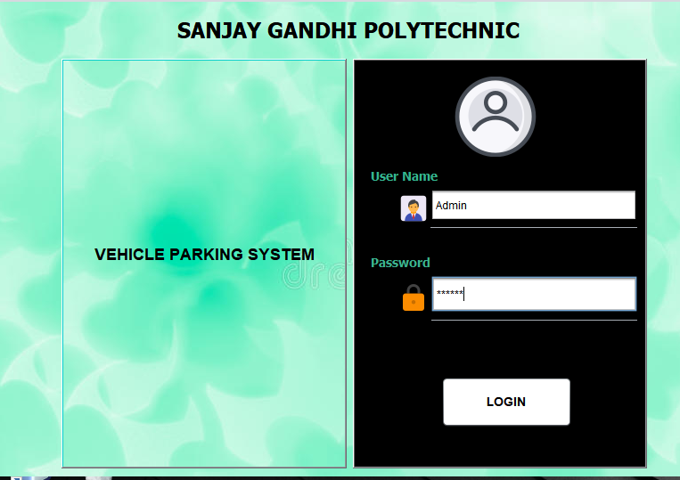

**Fig 8.1: Authentication**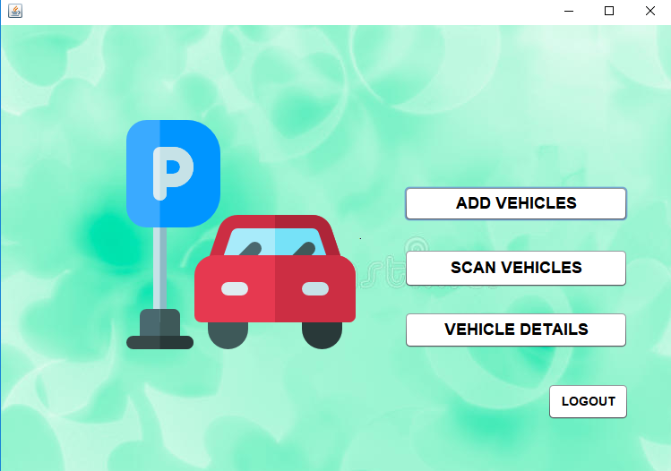

**Fig 8.2: Options**

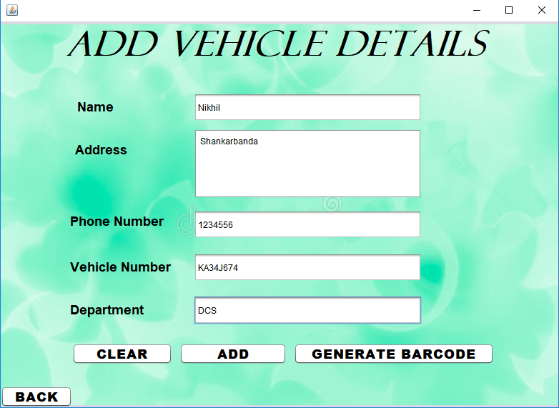

**Fig 8.3: Add vehicle details**

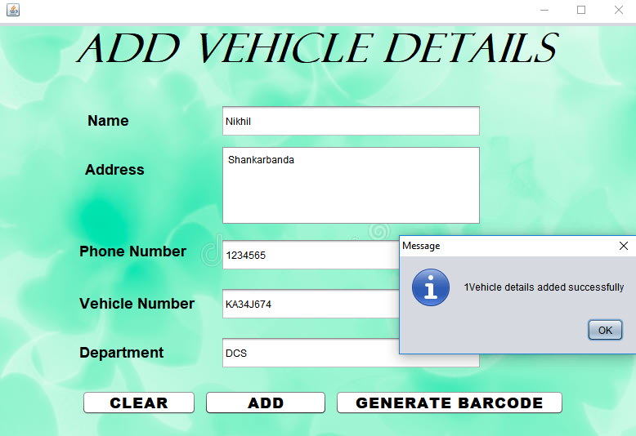

**Fig 8.4: Successfully adding into database**

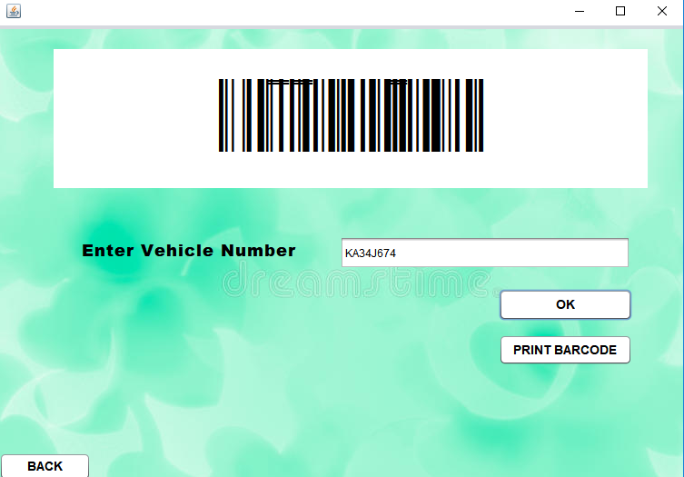

**Fig 8.5: Generate barcode**

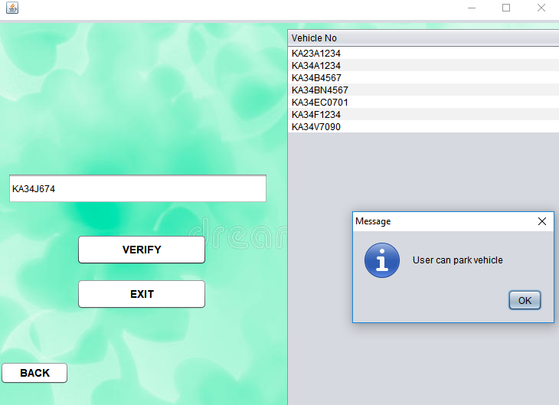

**Fig 8.6: Scanning of vehicle**

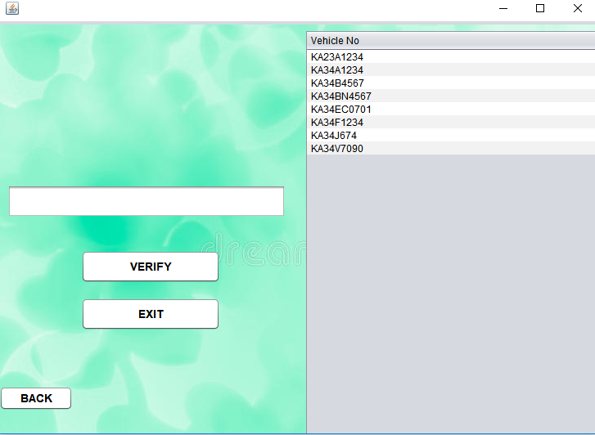

**Fig 8.7: Verified vehicle**

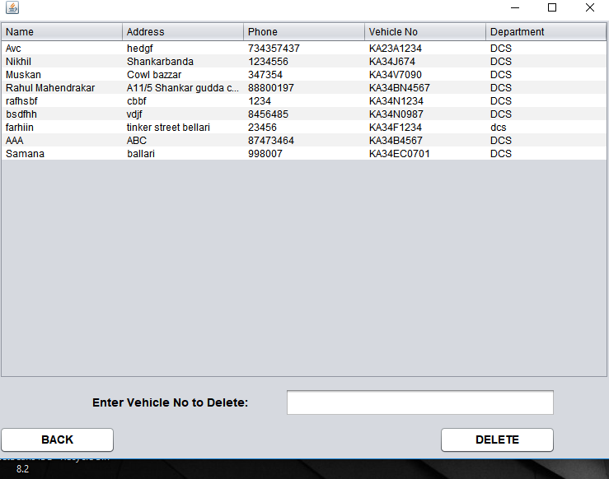

**Fig 8.8: Vehicle details of database**

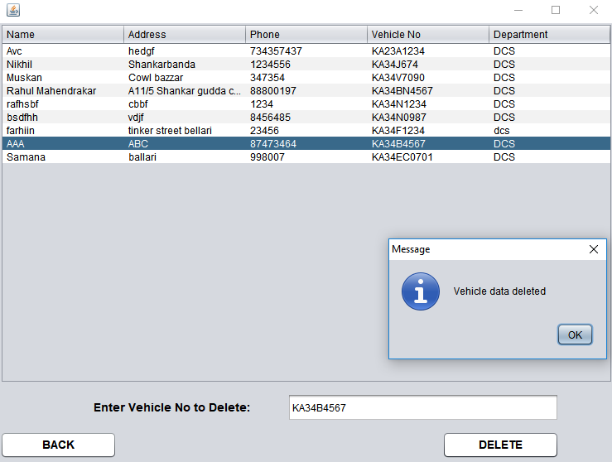

**Fig 8.9: Deletion of vehicle data**

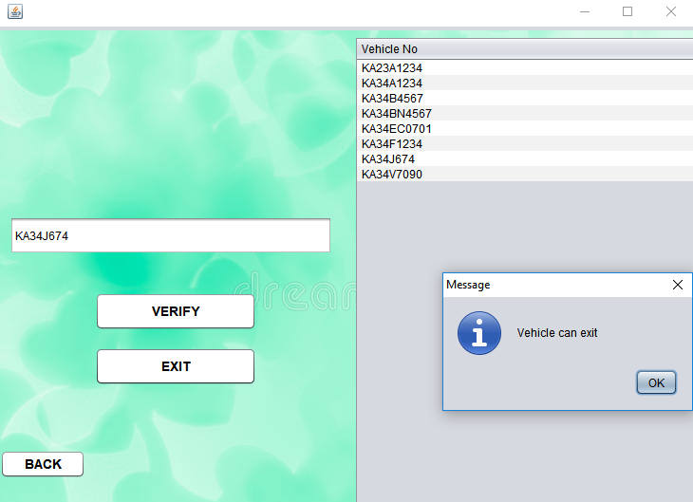

**Fig 8.10: Exit of vehicle**

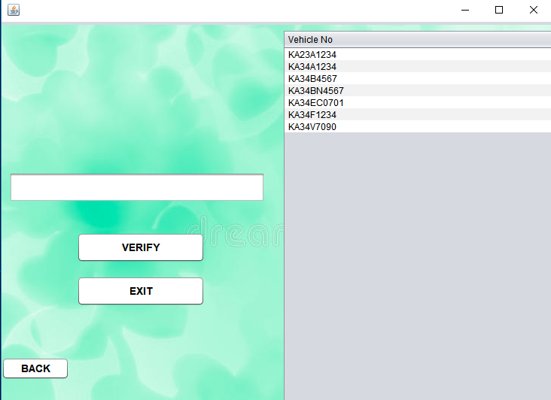

**Fig 8.11: Exit details**

**CHAPTER-9**

**9. FUTURE ENHANCEMENTS**

In future we can add the time-in and time-out of vehicle. Price calculation along with penalty can also be implemented. Using sensors we can detect the availability of the parking slots. Different types of barcodes can be used for enhancing. Advanced barcode readers can be used in future.

**CHAPTER-10**

**10. CONCLUSION**

From a proper analysis of positive points and constraints on the component, it can be safely concluded that the product is a highly efficient GUI based component. This application is working properly and meeting to all user requirements. This component can be easily plugged in many other systems.

**CHAPTER-11**

**11. REFERENCES & BIBILOGRAPHY**

- Herbert Schildt, Java Complete Reference, 5th edition

- Dietel and Dietel, Java How To program

- Pressman, Software Engineering, 4th edition

- Raghurama Krishnan, Database Management Systems

- <http://www.java.sun.com>

- <http://www.oracle.com>

-Swing: A Beginners’s Guide